Reading
Wow, what an exciting time it is at Simon Marks with reading! We have had a real push on reading, to ensure all children have access to high quality texts. We currently use the Oxford Reading tree in our class reading sessions, children take these home to read with their family, also children can take a book corner book and a Library book.
Key stage two reading:
Destination Reader is a new approach to teaching reading in KS2. The approach involves daily sessions incorporating whole class modelling, prior to the children applying these skills through partner work and independent reading. Destination reader has helped our children to deepen their understanding of the texts they read through the systematic use of a series of strategies and language stems.
Library:
Our library has seen great improvements recently, with a wonderful new selection of fiction and non-fiction books. These include a good selection of Jewish studies text and religious stories.

Phonics
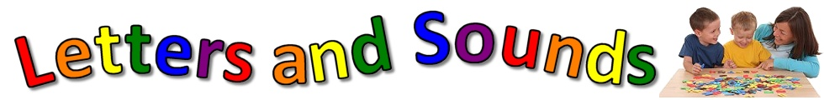
In the EYFS, the children begin a programme of synthetic phonics. The children experience a very interactive, multi-sensory approach to the teaching of synthetic phonics following the ‘Letters and Sounds’ programme- incorporating a methodical approach of revisit and review, teach, practise and apply. The children work through the phases progressively and at a pace which fully embeds their learning.
The Year 1 Phonics Screening check
The phonics screening check is a statutory assessment for all children in Year 1.
The phonics screening check will take place during the summer term and parents are informed about their child’s success in this. The phonics screening check is designed to confirm whether individual children have learnt phonic decoding to an appropriate standard. Children who do not achieve the appropriate standard should receive support from their school to ensure they can improve their phonic decoding skills. These children will then be expected to retake the phonics screening check the following year.
The phonics screening check comprises a list of 40 words that children read one-to-one with a teacher. The list is a combination of both real and pseudo-words. Using pseudowords allows this assessment to focus purely on decoding using phonics. As pseudo-words are new to all children, they do not favour children with a good vocabulary knowledge or large visual memory of words. The pseudo-words will be shown to children alongside pictures of imaginary creatures. This allows teachers to explain to the child that the pseudo-word is the name of a type of creature they haven’t seen before. This helps children to understand they should not try to match the pseudo-word to their vocabulary.

